**Assignment 4: Resolve Merge Conflicts**

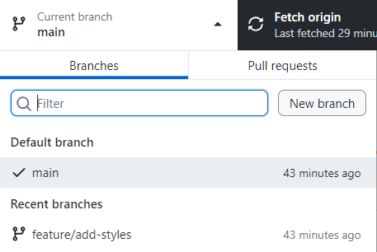

1. **Create a branch**:
   * Create a **new branch** called **feature/add-content**.

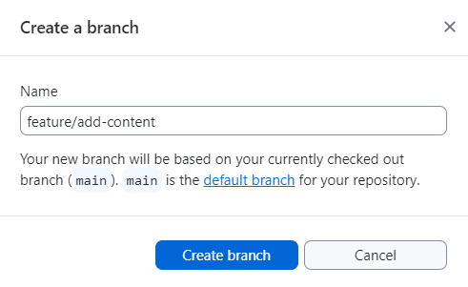

1. **Add content**:
   * In **index.html**, add a paragraph inside the **<body>:**

<p>This is some new content.</p>

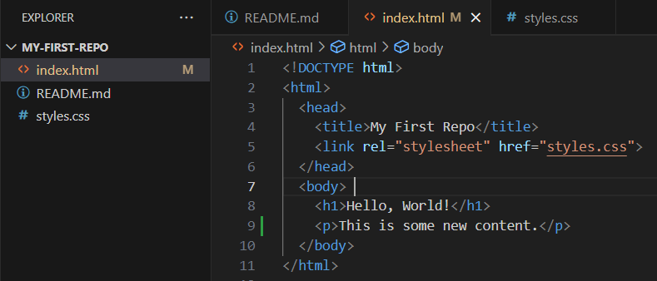  
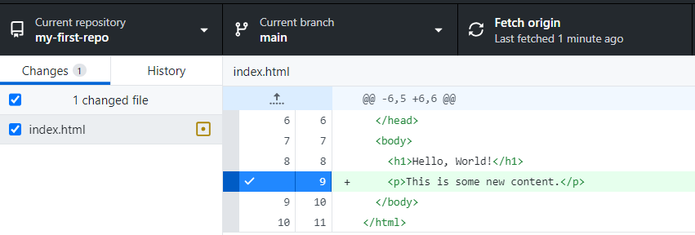

* + **Commit** and **push** the changes.  
    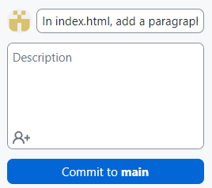

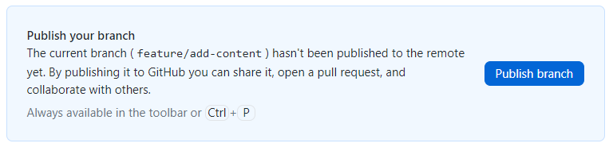

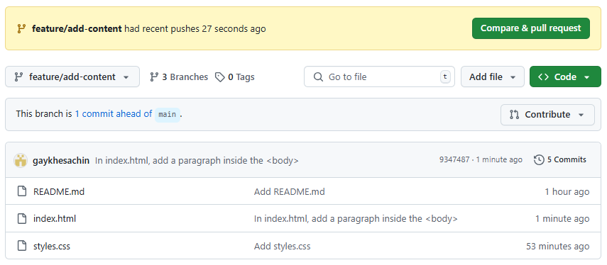

1. **Switch to main and make changes**:
   * Switch back to the **main branch**.  
     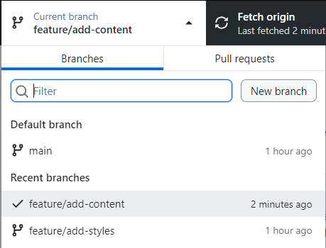
   * Edit the same part of **index.html** (e.g., change the paragraph text).  
     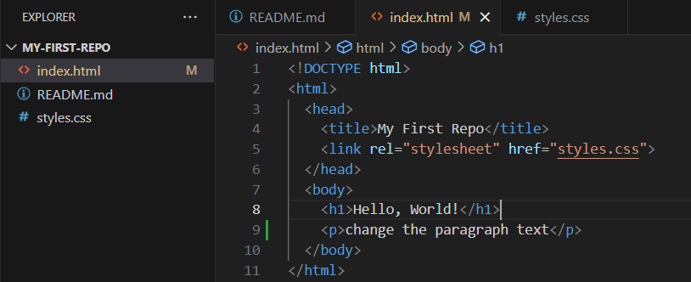

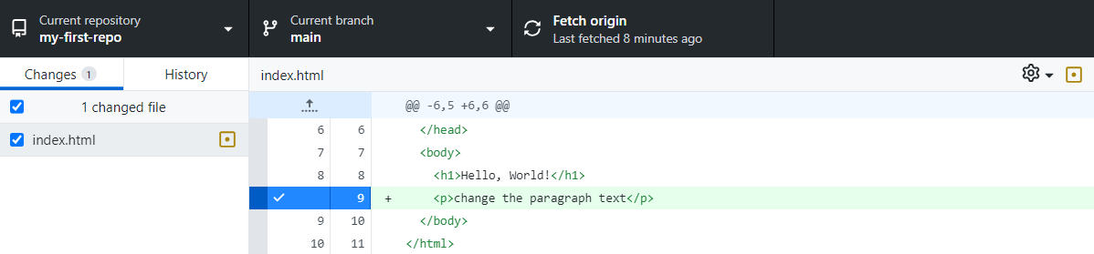

* + **Commit** and **push** the changes.  
    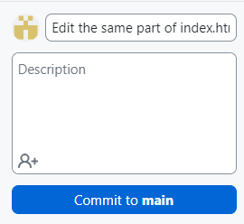

1. **Merge and resolve conflicts**:
   * Try to merge**feature/add-content** into **main**.

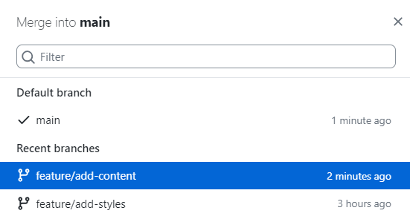  


* + GitHub Desktop will show a **conflict**. 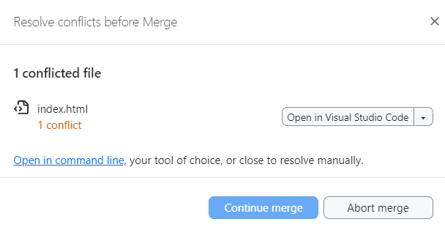



* + Open the **file** and **resolve** the conflict by choosing the **correct changes** or **combining them**.

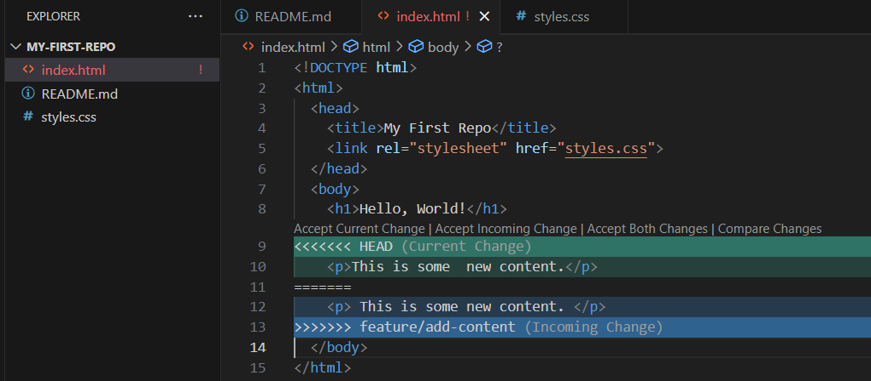

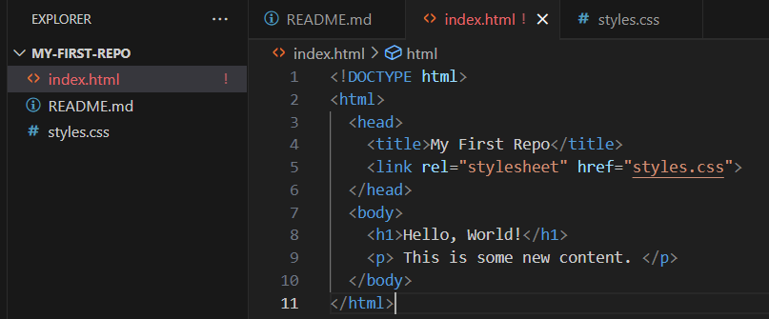

* + Mark the **conflict as resolved**, commit the **merge**, and **push**.

